**Nikita Mhase**

**Career Development Analysis Dashboard (3):**

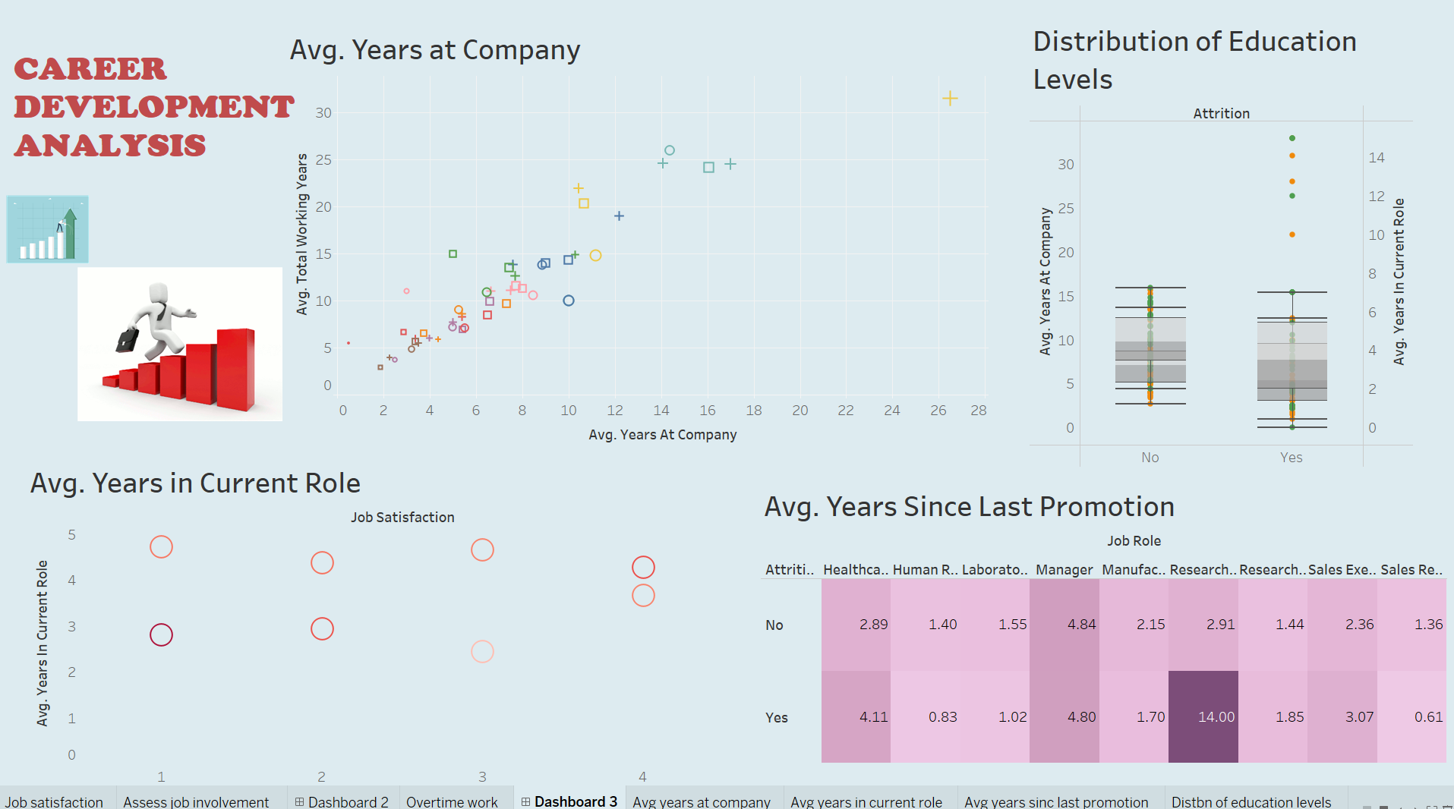

**1. Review Years at Company:**  
   Analyze the average number of years employees have been with the company. Identify any trends or discrepancies across different departments or employee groups.

HERE, avg. year for current role ranges from 0 to 15 and the plot represents a scatter plot so we are expecting a linear regression line and the points out of the line may be considered as outliers and need to be treated.

So the points which are outlier are detected and they are laboratory technician, sales executive, manufacturing director and 2 points as research director and 4 for manager. Also we checked for the business travel category and we can see it does not influence the attrition count.

**2. Assess Years in Current Role:**  
   Evaluate the average number of years employees have been in their current roles. Look for any patterns or correlations with factors such as job satisfaction or performance.

HERE, we can see avg. years in current role is approximately 3.3 and the years less than that have the attrition count so people not working more than 3 years have higher chances of leaving the job.

Also job satisfaction is also considered as one of the factor and in that the rating less than 2 have attrition count.

**3. Evaluate Years Since Last Promotion:**  
   Review the average number of years since employees were last promoted. Identify any departments or roles where employees have gone extended periods without promotion.

HERE, the highest year gap of last promotion is 14 years, and the attrition count is high also the period at which highest attrition count can be seen is 4 yrs or over yrs. Sometimes also 1 year gap leads to attrition in the job roles like are laboratory technician, sales executive, manufacturing director, sales representative.

**4. Examine Distribution of Education Levels**:  
   Explore the distribution of employees' education levels across the organization. Determine if there are any correlations between education level and career advancement.

HERE, the analysis is done through boxplot based on the education levels provided as we know there is upper and lower whiskers and points outside the whiskers are considered as outliers. So from the Outliers we come to know are life sciences, marketing and technical degree representing job roles as research director, and manager.

**5. Identify Areas for Improvement:**  
   THE areas for improvement of job roles based on all the dashboards created are research director, laboratory technician, sales executive, manufacturing director, sales representative.

So, all these are the common fields of job roles for improvements. And the reason can be large gap of promotion provided.

**Propose Strategies for Advancement:**  
   THE strategies can be like we can give promotions to people after 2 years period so attrition count will be less also include less people from sales and life sciences dept. and look for people who have done the course with some other major as human resources dept. as they have least attrition count. Also the one who are not getting promotions we can give them a offer such as complete a crash course of the skills we need in the company and then you will get cash prize or a certain promotion according to the policy created by the company. Because of these continuous learning as well as promotion would be done profiting in company’s benefit and leading to less attrition count.